# CHAPTER THREE

# METHODOLOGY OF THE STUDY

## 3.1 INTRODUCTION

According to findings from reviewed literatures, some Human Resource Management System were evaluated and this was aimed at investigating the current system requirements, strengths and challenges. The system analysis is an integral part of the software development process as it enables the developer to ascertain the effectiveness and efficiency of the proposed system and also determine whether it meets the desired objectives.

## 3.2 SYSTEM ANALYSIS

System analysis can be appropriately described as the process of gathering and interpreting facts, diagnosing problems, and using the information to recommend improvements to the system. This process answers the questions of who will use the system, what will the system do, and where and when it will be used (*Dennis, Wixom & Roth*, 2012). It is a problem solving technique that decomposes a system into its component pieces for the purpose of the studying how well those component parts work and interact to accomplish their purpose. It is the detailed study of the current system that leads to the specification of a new system. At this stage the existing system is thoroughly dissected and evaluated, in order to identify its strengths and weaknesses, and thus, specify the essential user requirements and objectives on which the proposed system will be built upon.

**3.3 DATA COLLECTION**

An important step in the development of Human Resource Management System successfully is to select an appropriate method of data gathering or collection. The approaches which have been used include

1. Internet research and review: This domain gives a suitable area for informational searching and sharing without travelling.
2. Interview of staff in establishment section (University of Ilorin, HR Department)
3. Journals: the unlimited access to articles without time restriction has made great part for the establishment of this research.

## 3.4 DESCRIPTION OF THE EXISTING SYSTEM

The current system available in the Human Resource Department of University of Ilorin assumes the use of form fills, physical meetings, letters for recommendations, leaves and promotion. Staff either have to wait till they meet face to face in other to meet to their needs. The data flow and attitude management concerning the welfare of the workers is vital to an organization. With the manual method of management in the Human Resource Department, some areas such as staff data control, recommendations and promotions appraisal need conversion that will be most suitable by computerized method.

## 3.5 PROBLEMS OF THE EXISTING SYSTEM

Currently as far as we are aware during this study, there is no existing sophisticated electronic system within the university that can be used for management of staff. The current system does not only lead to time wastage on data processing, storage, retrieval of information, poor data and information flow within the organization, it is also filled with limitations which can make the entire process ineffective.

Furthermore, we might have some information printed on our desk, some files stored on various computers for which there is really no record. When certain information is to be retrieved, it cannot easily be tracked and recovered majorly because of poor organization.

## 3.5 IMPROVEMENT OF THE PROPOSED SYSTEM OVER THE EXISTING SYSTEM

The Proposed system is an online system for all the information of staff. It provides file sharing, messaging, an efficient human resource management and an overall infrastructure supporting additional subsystems in future. This application software keeps track of each staff in the department.

The proposed system is one that will fully adopt the use of Information and Communication Technologies (ICTs), to simplify the process of carrying out the activities the application will be targeted at and create an application that can run on the web as well as on the mobile phones of its desired users.

## 3.6 PROPOSED SYSTEM MODEL

The proposed system is built with a PHP Framework. **PHP framework** is a library that makes the life of site developer easier by for example hiding some complexities of HTTP protocol or by adding some useful functions (StackOverflow, 2016). It works well with the Unified Modeling Language which is used for the purpose of this project.

# 

# 3.6.1 A PHP FRAMEWORK: LARAVEL

Laravel is a prominent member of a new generation of web frameworks. It is a free, open-source PHP web framework, created by Taylor Otwell back in 2011 and intended for the development of web applications following the MVC model.

Some of the features of Laravel are:

* modular packaging system with a dedicated dependency manager
* different ways for accessing relational databases though Routing
* utilities that aid in application deploymentand maintenance
* orientation toward syntactic sugar
* easy authentication by providing a simple & easy to use interface and many more.

Laravel is a prominent member of a new generation of web frameworks. It is a free, open-source PHP web framework, created by Taylor Otwell and intended for the development of web applications taking after the model–view–controller (MVC) architectural pattern. Some of the features of Laravel are a secluded packaging system with a dedicated dependency manager, different courses for accessing relational databases, utilities that guide in application deployment and maintenance, and its orientation toward syntactic sugar.

Laravel offers the following key features:

* Modularity
* Testability
* Routing
* Configuration management
* Query builder and ORM (Object Relational Mapper)
* Schema builder, migrations, and seeding
* Template engine
* E-mailing
* Authentication
* Redis
* Queues
* Event and command bus

Laravel is referred to as a “full stack” framework because it handles everything from web serving to database management right down to HTML generation.

Laravel follows the **model-view-controller (MVC)** architectural pattern, which enforces a separation between “business logic” from the input and presentation logic associated with a graphical user interface (GUI). In the case of Laravel web applications, the business logic typically consists of data models for things like users, blog posts, and the GUI is just a web page in a web browser. The MVC design pattern is very popular in the web development space.

There are three components to the MVC pattern:

* The **Model** represents your data structures. Typically, your model classes will contain functions that help you retrieve, insert, and update information in your database.
* The **View** is the information that is being presented to a user. A View will normally be a web page, but in Laravel, a view can also be a page fragment like a header or footer. It can also be an RSS page, or any other type of “page”.
* The **Controller** serves as an *intermediary* between the Model, the View, and any other resources needed to process the HTTP request and generate a web page.

## COMPONENTS OF LARAVEL

A typical Laravel application consists of the above mentioned MVC components, as you can see below:

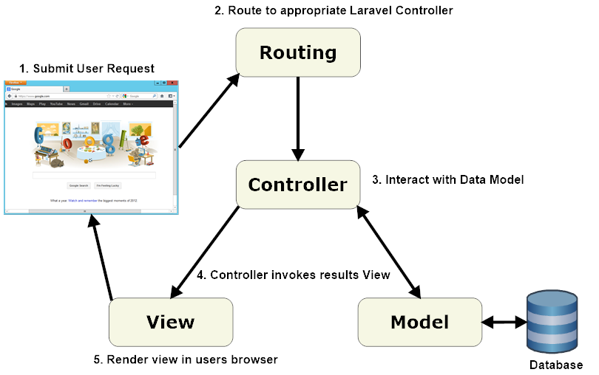

#### Figure 1: Laravel Application Flow Chart

When interacting with a Laravel application, a browser sends a request, which is received by a web server and passed on to the Laravel routing engine. The Laravel router receives the request and redirects to the appropriate controller class method based on the routing URL pattern.

# 3.6.2 ANALYSIS OF MODULES INVOLVED

The application will be designed using Laravel, a PHP Framework. As stated earlier, Laravel is based on the MVC approach. The graphical aspect of the application, that is the Views, will be structured using a framework called bootstrap which would be called through the blade templating engine which is available in Laravel.

Bootstrap is the most popular HTML, CSS and JavaScript framework for developing responsive, mobile-first web sites.

For testing the application, we will make use of a local server called XAMPP.

XAMPP is the most popular PHP development environment. It is free, easy to install Apache distribution containing MariaDB, PHP and Perl.

# 3.6.3 UNIFIED MODELING LANGUAGE (UML)

The Unified Modeling Language (UML) is a general-purpose modeling language in the field of software engineering, which is designed to provide a standard way to visualize the design of a system. The Unified Modeling Language (UML) offers a way to visualize a system's architectural blueprints in a diagram, including elements such as:

* All activities
* Individual components of the system
* How they can interact with other software components
* How the system will run
* How entities interact with others (components and interfaces)
* External user interface

The UML consists of many types of diagrams which are divided into two categories. Some types represent structural information, and the rest represent general types of behavior, including a few that represent different aspects of interactions. The structure diagram consists of the class diagram, component diagram and object diagram; while the behavioral diagram consists of the use case diagram and the activity diagram.

# 3.6.4 CLASS DIAGRAM

In software engineering, a class diagram in the Unified Modeling Language (UML) is a type of static structure diagram that describes the structure of a system by showing the system's classes, their attributes, operations (or methods), and the relationships among objects. The class diagram for the proposed project is shown below:

THERE IS A STAR UML DIAGRAM OF THE USE CASE DIAGRAM I SENT BUT NEEDS MODIFICATION

#### 

#### Figure 2: Use Case Diagram

A Use Case Diagram at its simplest is a representation of a user’s interaction with the system that shows the relationship between the user and the different use cases in which the user is involved. In this case, the users are the staff, Head of Department, Dean and HR Administrators related to the University of Ilorin.

Use cases describe a sequence of actions that provide something of measurable value to an actor and is draw as a horizontal ellipse.

An actor is a person, organization, or external system that plays a role in one or more interactions with your system. Actors are drawn as stick figures.



*Figure 3: HR Admin Use Case Diagram*

## 3.6.6 DATABASE DESIGN

A relational database is used in the implementation of the project. Database is an essential component in a developed system and in this case it is used for information depository and retrieval. Following is the structure of various objects of the application:

**3.3.7 PROGRAM FLOWCHART**

A flowchart is a convenient technique to represent the flow in a program. It is a pictorial representation of an algorithm that uses symbols to show the operations and decisions to be followed by a computer in solving a problem. The following figure shows the flow of the system from when the HR Admin logs in

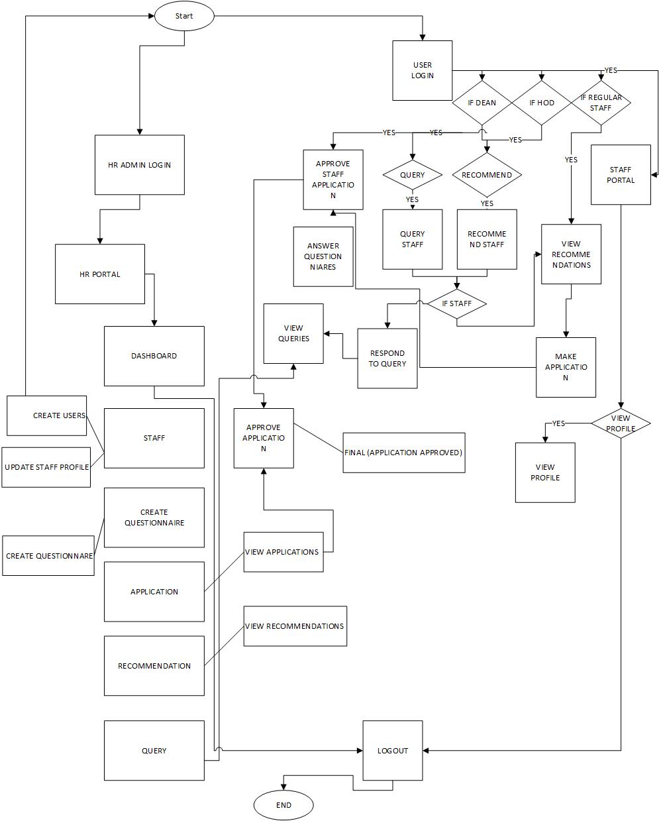

*Figure 5: Flowchart of the Proposed System*

**3.4 SOFTWARE MODEL ADOPTED AND THE RATIONALE FOR USE**

Taking the project’s framework and the given organizational structure into account, we considered is the ITERATIVE WATERFALL APPROACH most appropriate for the development of this Human Resource Management System. In this methodological framework, the progress of work will regularly be presented to the institutions involved, and in this case, the developers of the work will run a constant review.

In the Iterative Waterfall Model, feedback path are provided for error correction as and when detected later in a phase. Though errors are inevitable, it is desirable to test them in the same phase in which they occur. If so, this can reduce the effort to correct the bug.

The advantage of this model is that there is a working model of the system at a very early stage of development which makes it easier to find functional or design flaws. Finding issues at an early stage of development enables to take corrective measures in a limited budget.

The disadvantage with this SDLC (Software Design Life Cycle) model is that it is applicable only to large and bulky software development projects. This is because it is hard to break a small software system into further small serviceable increments/modules.

**3.5 DESIGN TOOLS**

3.5.1 BALSAMIQ MOCKUPS

Balsamiq Mockups is a graphical user interface (GUI) mock-up builder application. It allows the designer to arrange pre-built widgets using a drag-and-drop WYSIWYG (What You See is What You Get) editor. The application is offered in a desktop version as well as a plug-in for Google Drive, Confluence and Jira.

A website wireframe, also known as a page schematic or screen blueprint, is a visual guide that represents the skeletal framework of a website. They are created for the purpose of arranging elements to best accomplish a particular purpose. A wireframe basically depicts the page layout or arrangement of the website’s content, including interface elements and navigational systems, and how they work together. The wireframe in this case was used to plan for the development of the application. It provided a visual representation of what the application should look like based on different preferences, thus, serving as a guide in the development process.

3.5.2 SUBLIME TEXT

Sublime text is a sophisticated text editor for code, mark-up and prose. It is a great general purpose text editor that offers plenty of power to anyone working on websites. It is especially well suited to anyone wedded to the keyboard, providing powerful shortcut and tools to leap about a document, make (multiple) selections, filter the file, and quickly make edits. Switching between projects is also lightning fast – perfect for anyone juggling multiple clients. Sublime text may be downloaded and evaluated for free, but a licence must be purchased for continued use. Key features of sublime include:

* Goto anything (lightning fast search/shortcuts)
* Command palette
* Split editing
* Highly customisable
* Distraction free mode
* Instant project switch
* Plugin API

DBTABLES